Dr Tiernan

Tu Mai

UTA ID 1001594173

1.a) Please see file Lab2Part1.java in the Folder.

1.b) Please see my Lab2Part1bi-viSceenShot for this question.

1.c) What does your program do if the user enters something other than B, M, or T for their letter input ?

I put another case when people do not care much about the upper or lower case for the input. When the user entered the wrong letter other than upper of lower letter B, M, or T, it would say that the put in the wrong year or letter and ask them if they wanted to try again by putting in another value. After that the user can look at their input through the print out input line and fix it.

1.d) Yes, the program should give an error if year is not listed. It should show the year you have entered is not valid. When it was being searched, and compared the input with all years that listed with the letters, If the year that you input is not listed, it will show error and tell you that the year is invalid, then ask you for another input.

1.e) 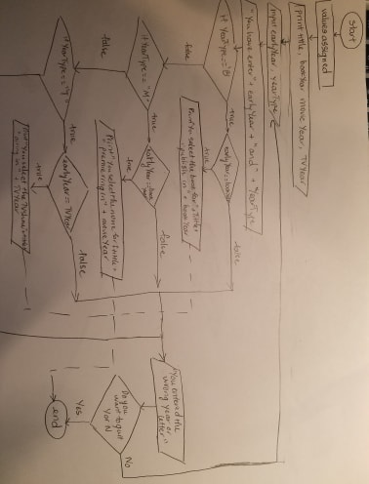

2.a) The program reverses the user’s input value by using Math. It extracts the digits of the number starting from the right one by one and add it to the result. The last digit of A is the same as the remainder obtained on dividing the number by 10. To remove the extracted number from A, it divides remainder of A and 100 by 10. The first digit is the result of A divine by 100. Because both A and divided number (10 or 100) are integer values, the resulting value will be an integer and not a decimal. Final step is to add the extract digit to the result which is Anot. This can be done by multiplying the result with 10 and adding the extracted digit to it. In case the number is not a 3-digit number, when doing the Math, it will turn to 0, and when it comes to the final step, 0 will be added in the number. For example, (0)29 will be reversed to 920

2.b) Please see file Lab2Part2biSceenShot – Lab2Part2bviSceenShot for this answer

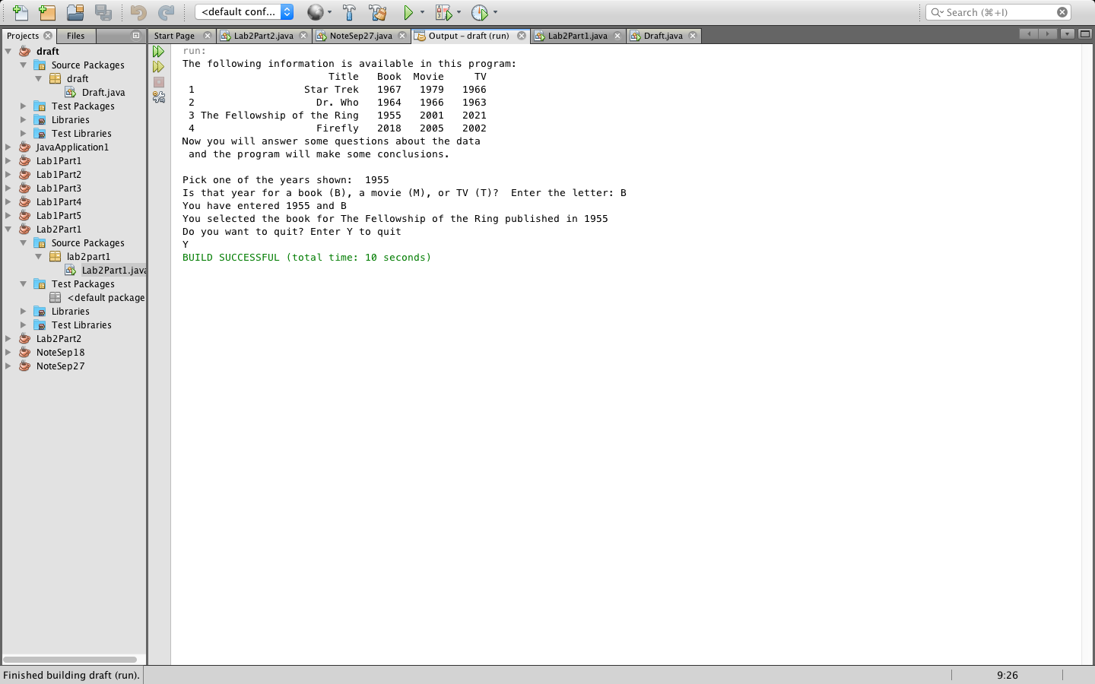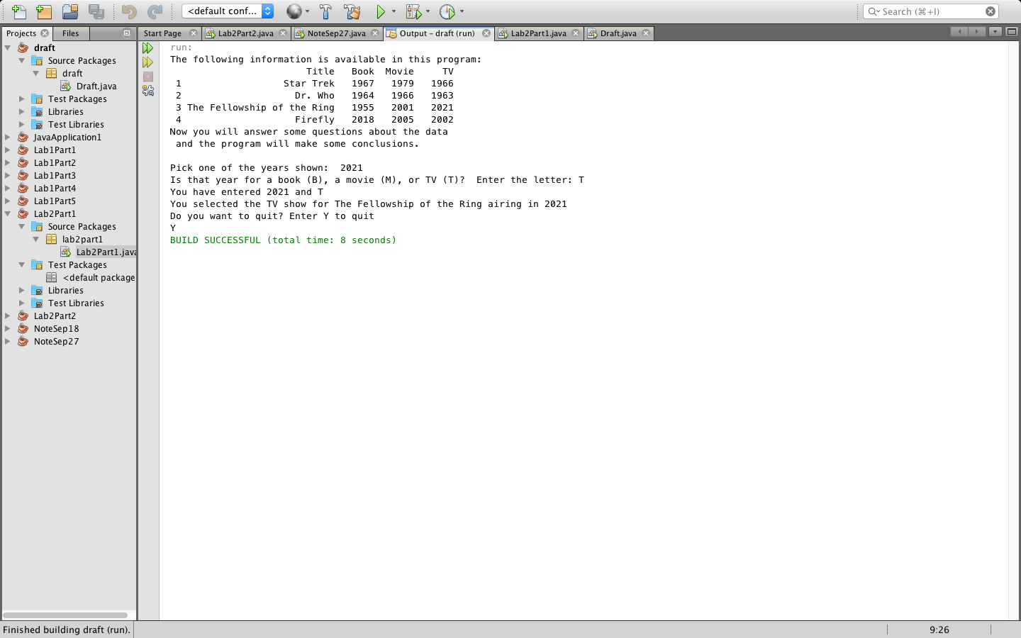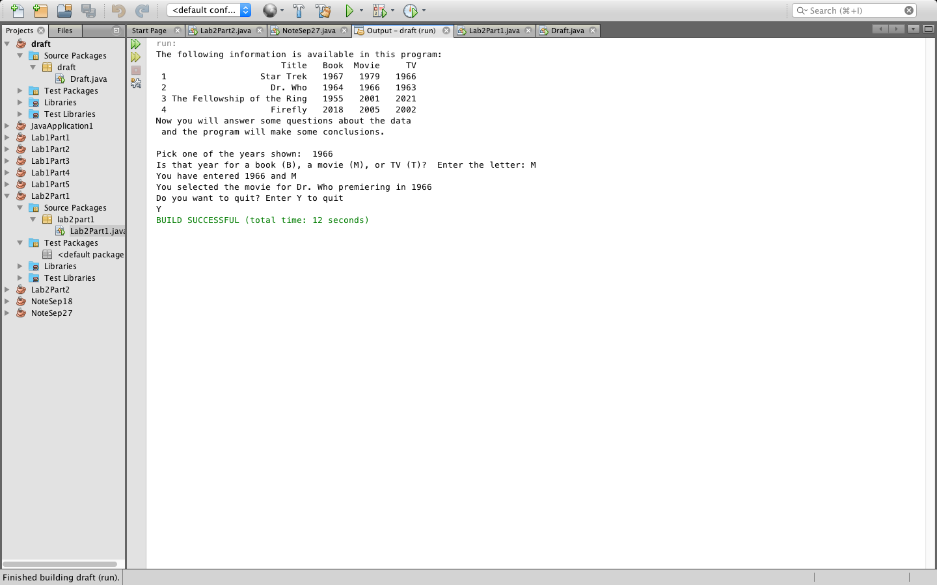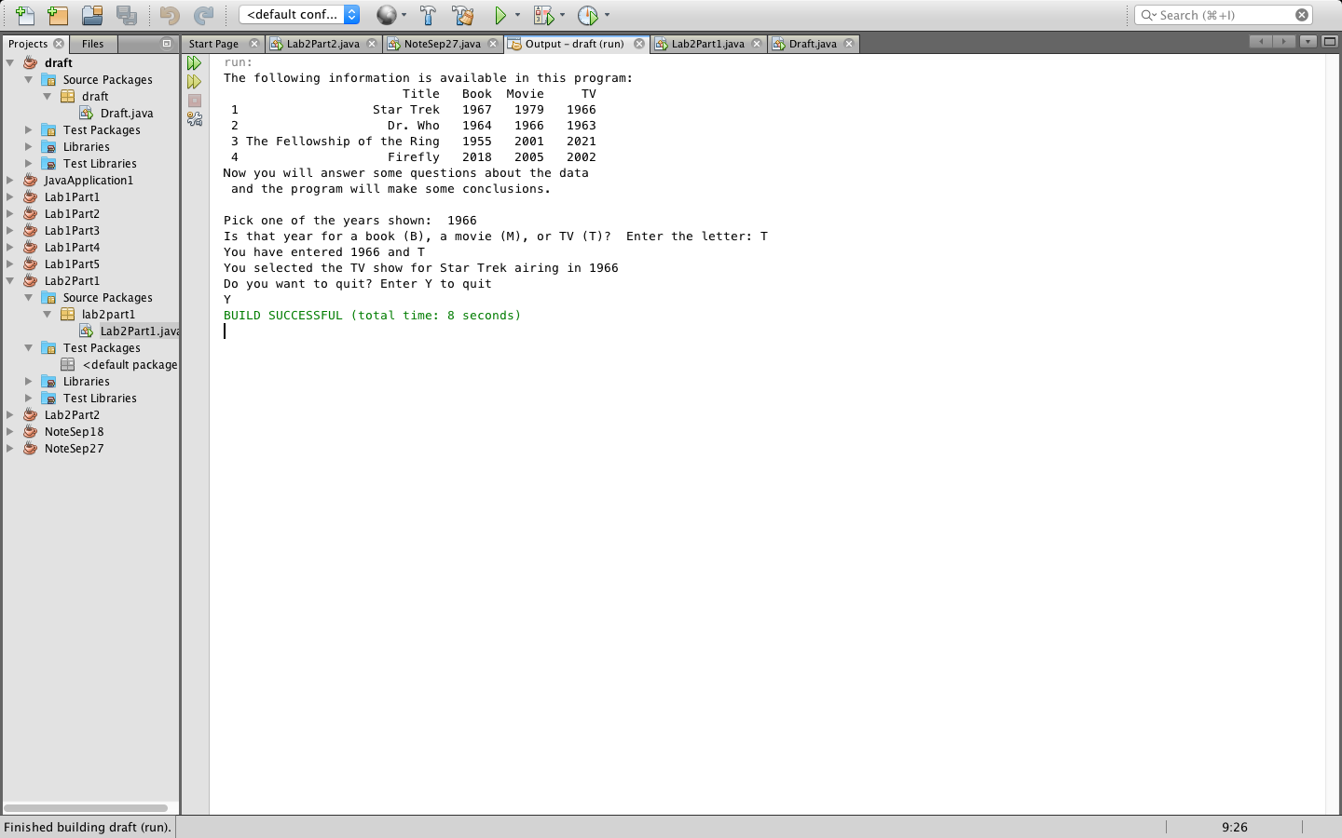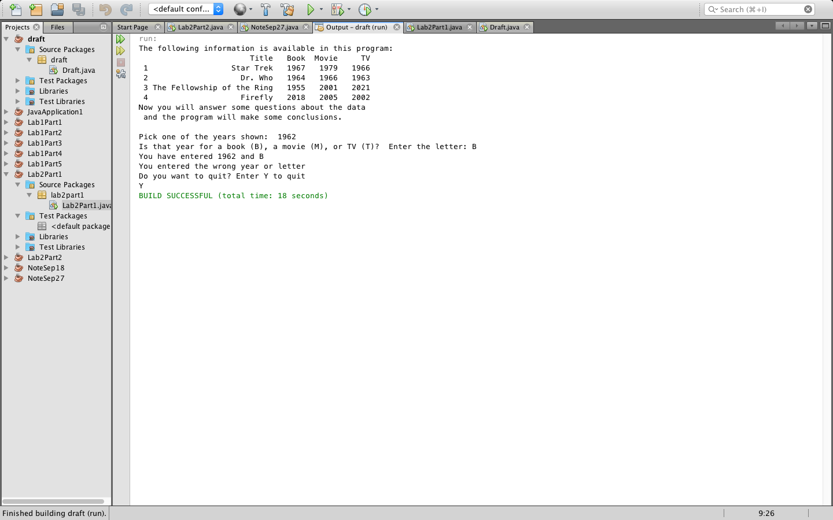

2.c) It still works because we do not have any conditions to tell the user know or to stop the program when user input a number that is not a three-digit number. When we input a number with one or two digit, after the reversing number, 92 will be understand as 092 and its reverse will be 290.

2.di) 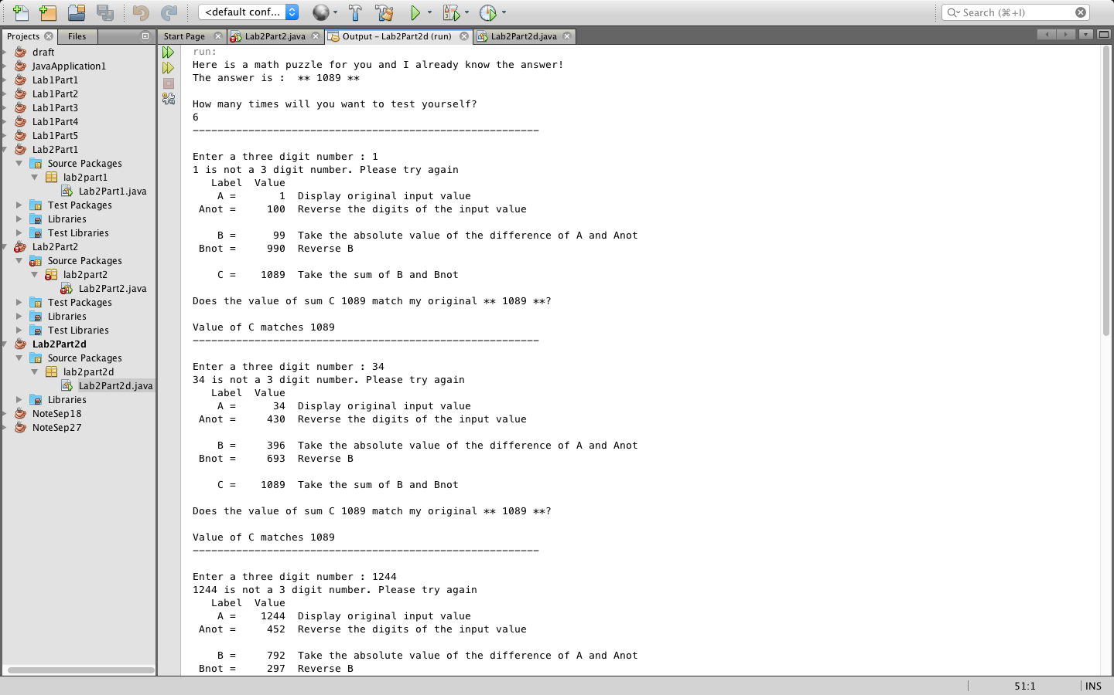

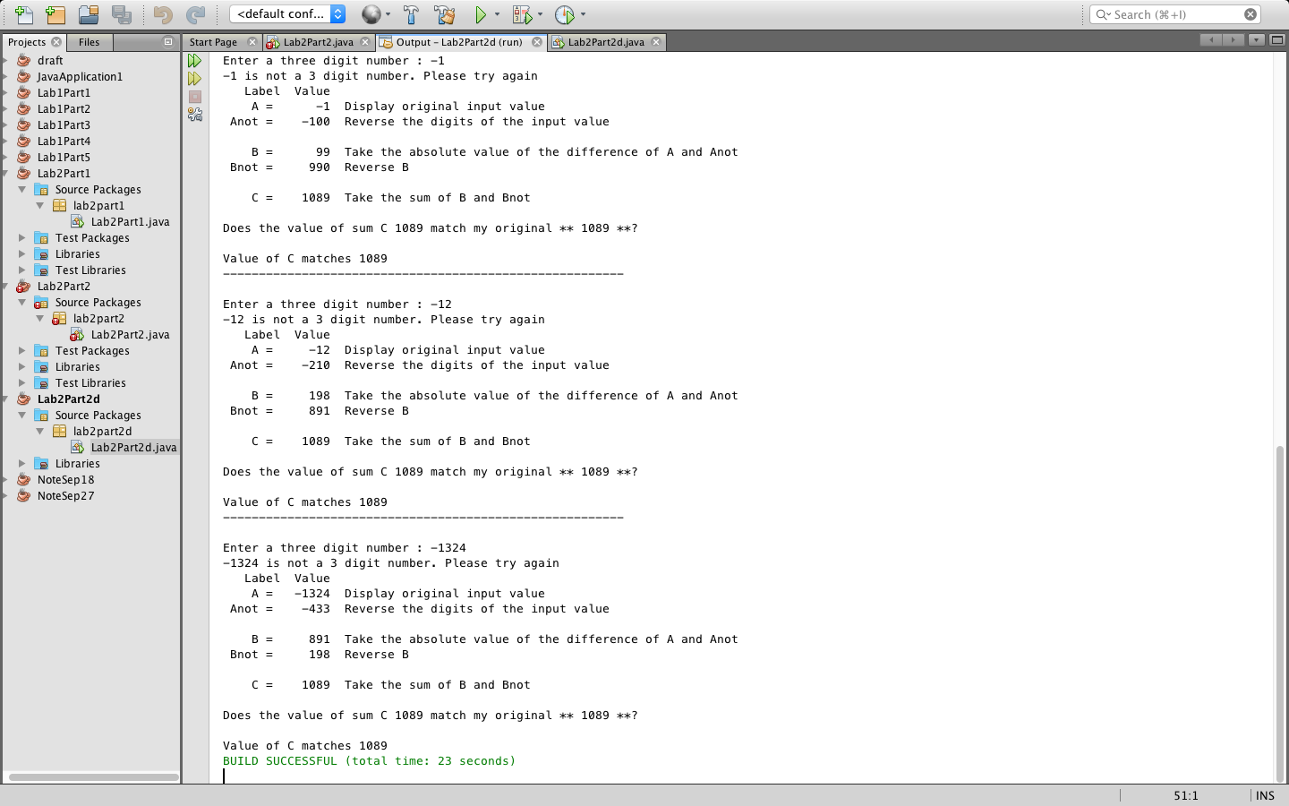

2.d.ii) No, it will not correctly handle invalid input because the process after the input was still running. We need to have a while loop to make sure if the input is invalid, it will ask user to input another value until it valid, then continue to run the program below.

2.d.iii) The output is You have entered an invalid number. Please re-enter 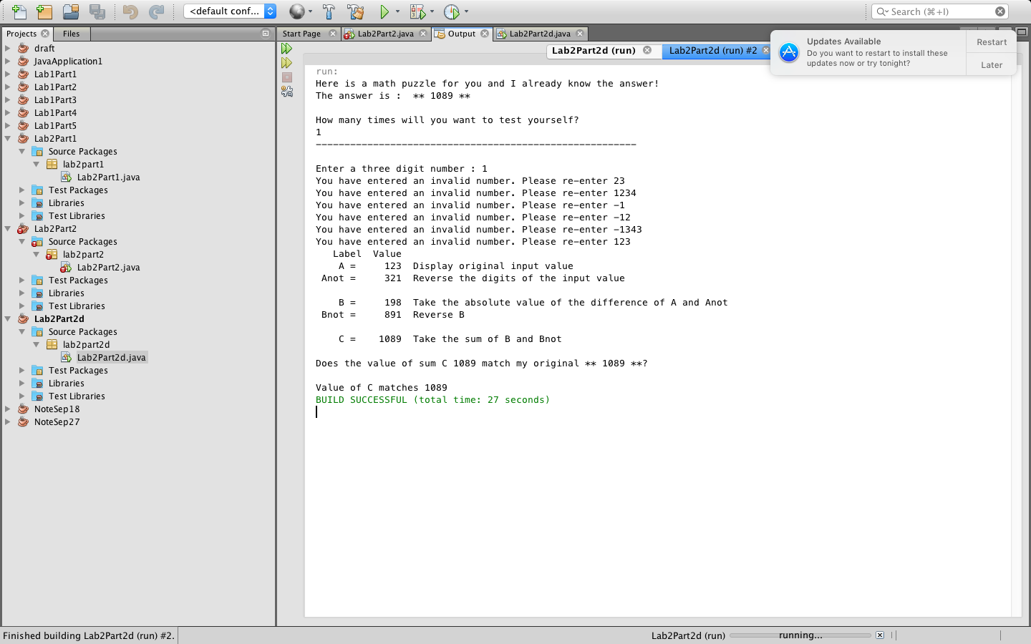

2.d.iv) Yes, The do-while statement handle invalid input correctly because it asks the user to input again until the input is 3-digit number

2.d.v) Please see Lab2Part2d.java for this question

2.e.i) 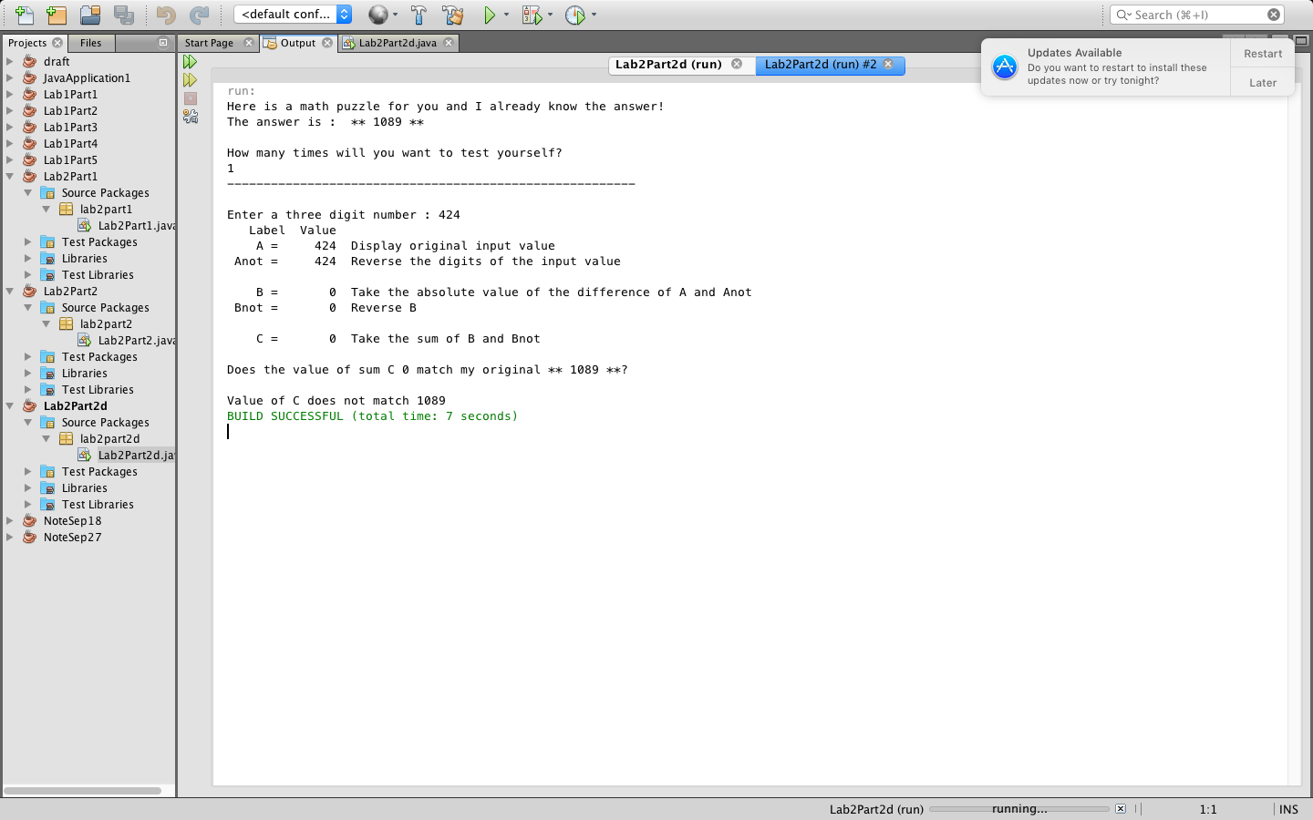

2.e.ii) 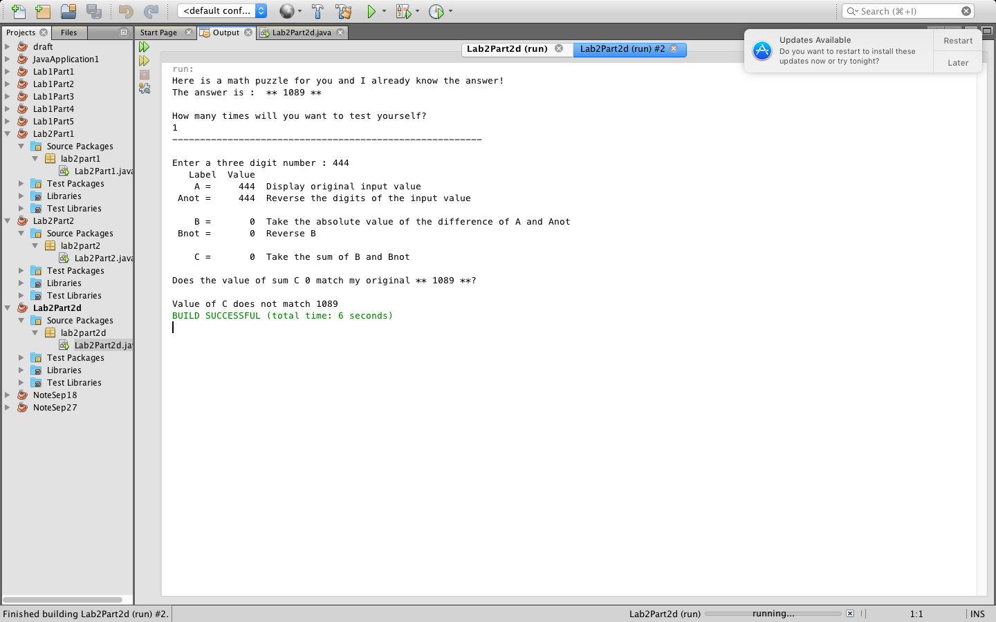

2.e.iii)

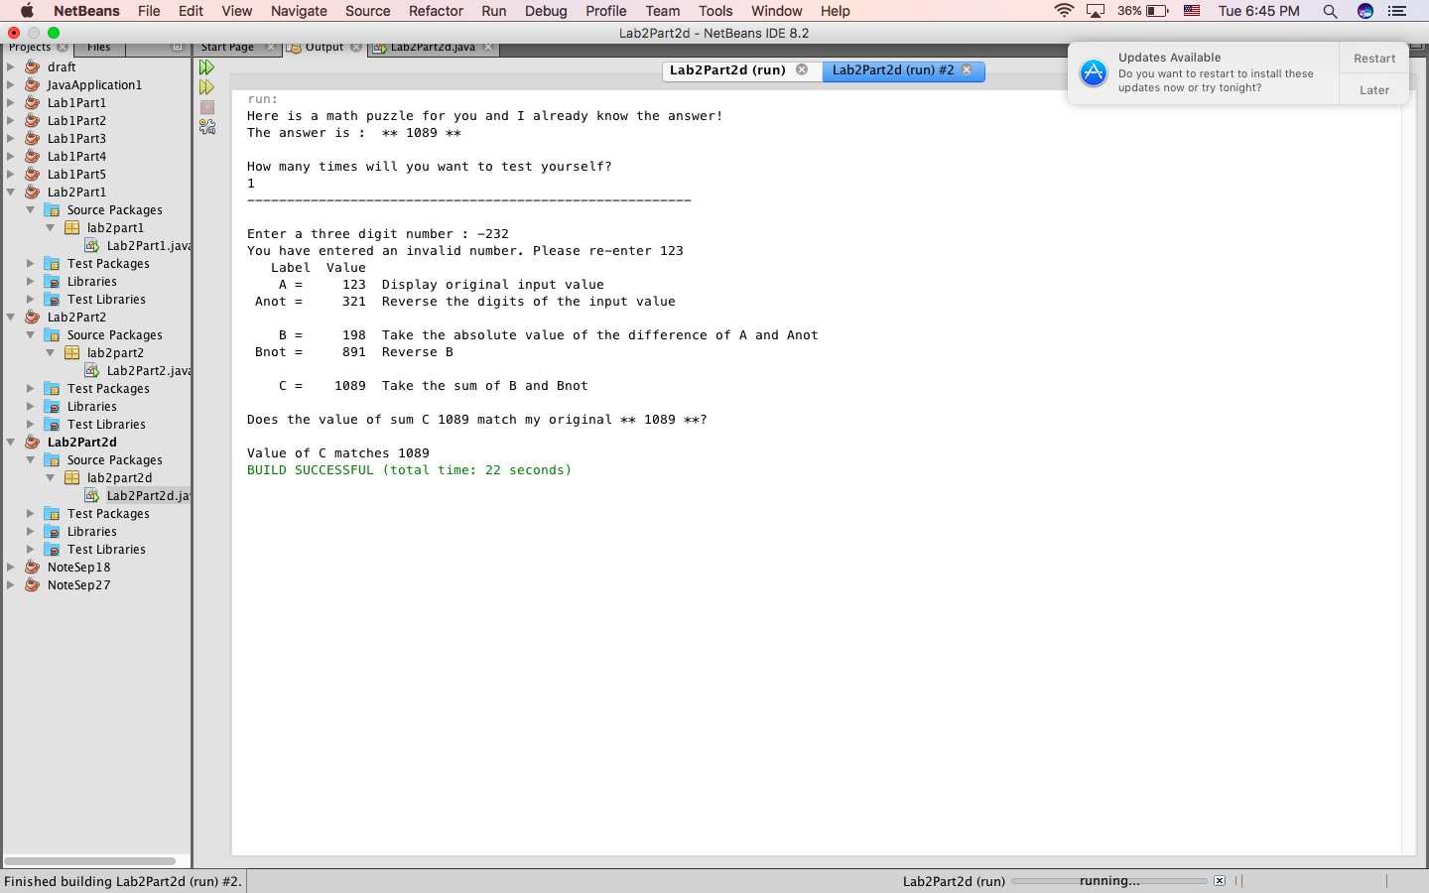

2.e.iv)

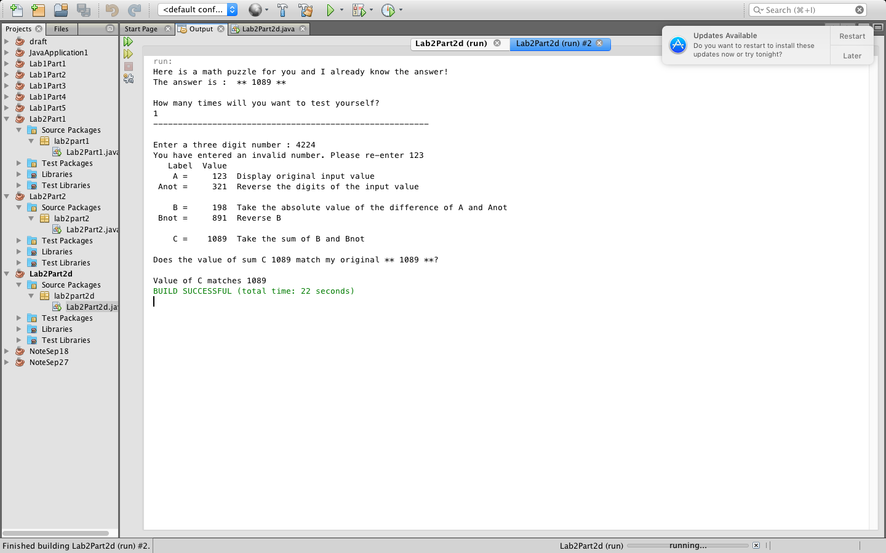

2.f) We have the reserve number of the input which is Anot. The only thing that we need to do is check to see if A (your input) equal to Anot. If yes, A is a palindrome because A is equal to its reversing number. If no, A is not a palindrome.

2.g)

Please see Lab2Part2g.java for this answer

2.g.i)

Run a test with a positive three-digit palindrome value with middle digit different from first and last.

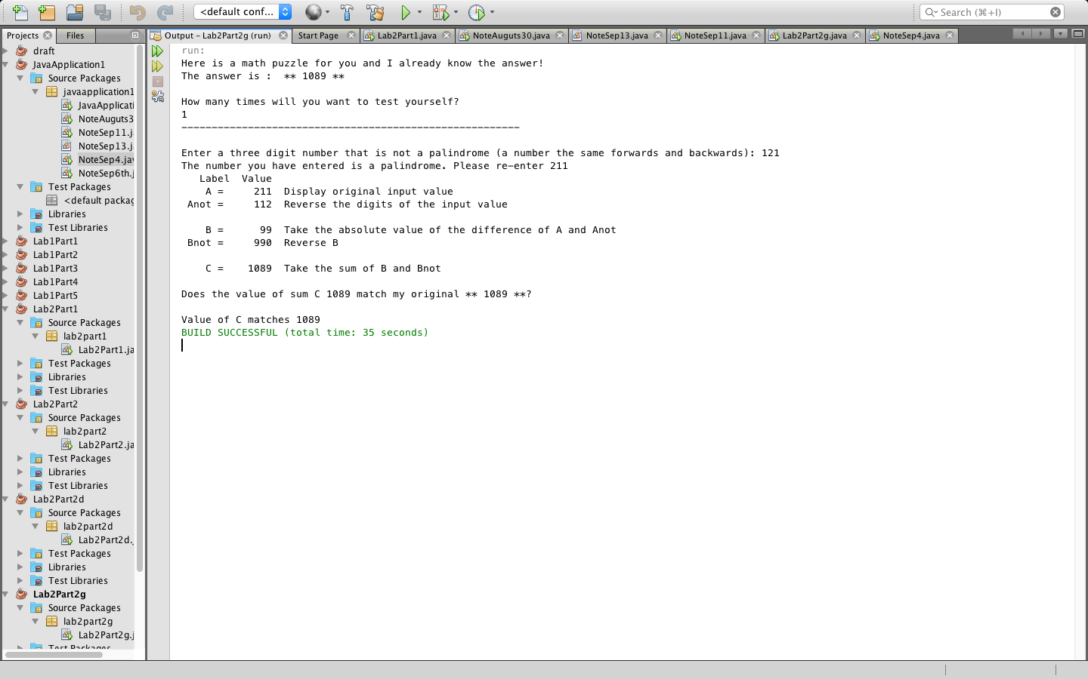

Run a test with a positive three-digit value with all digits the same

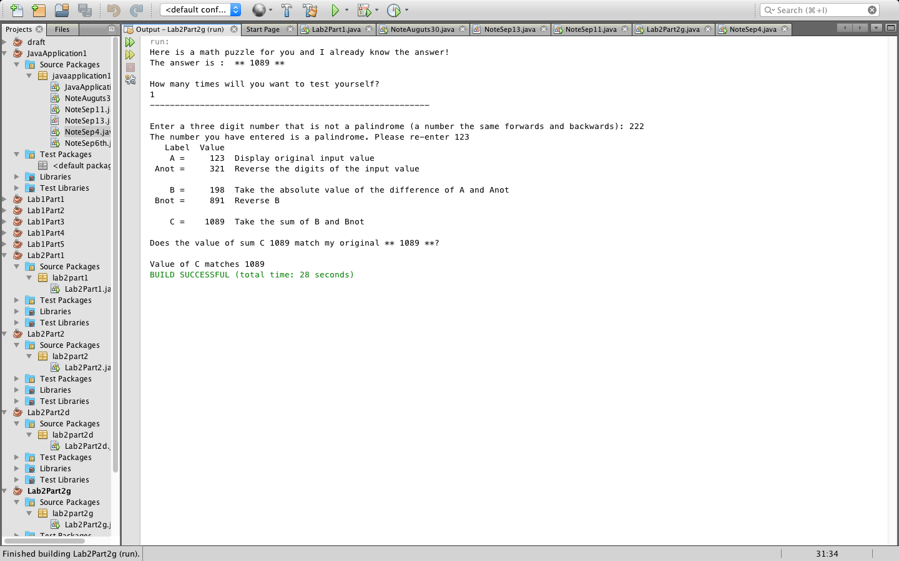

Run a test with a negative three-digit palindrome value

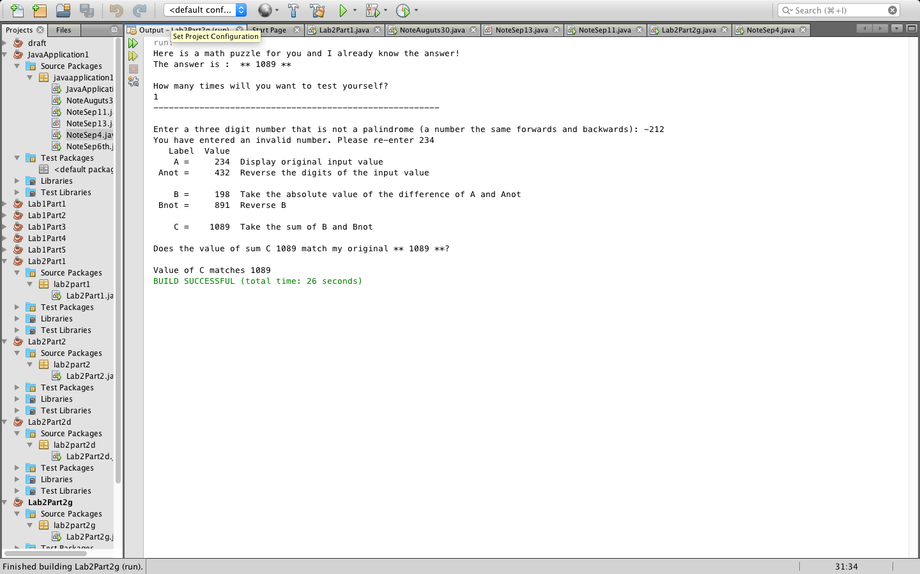

Run a test with a four-digit palindrome value

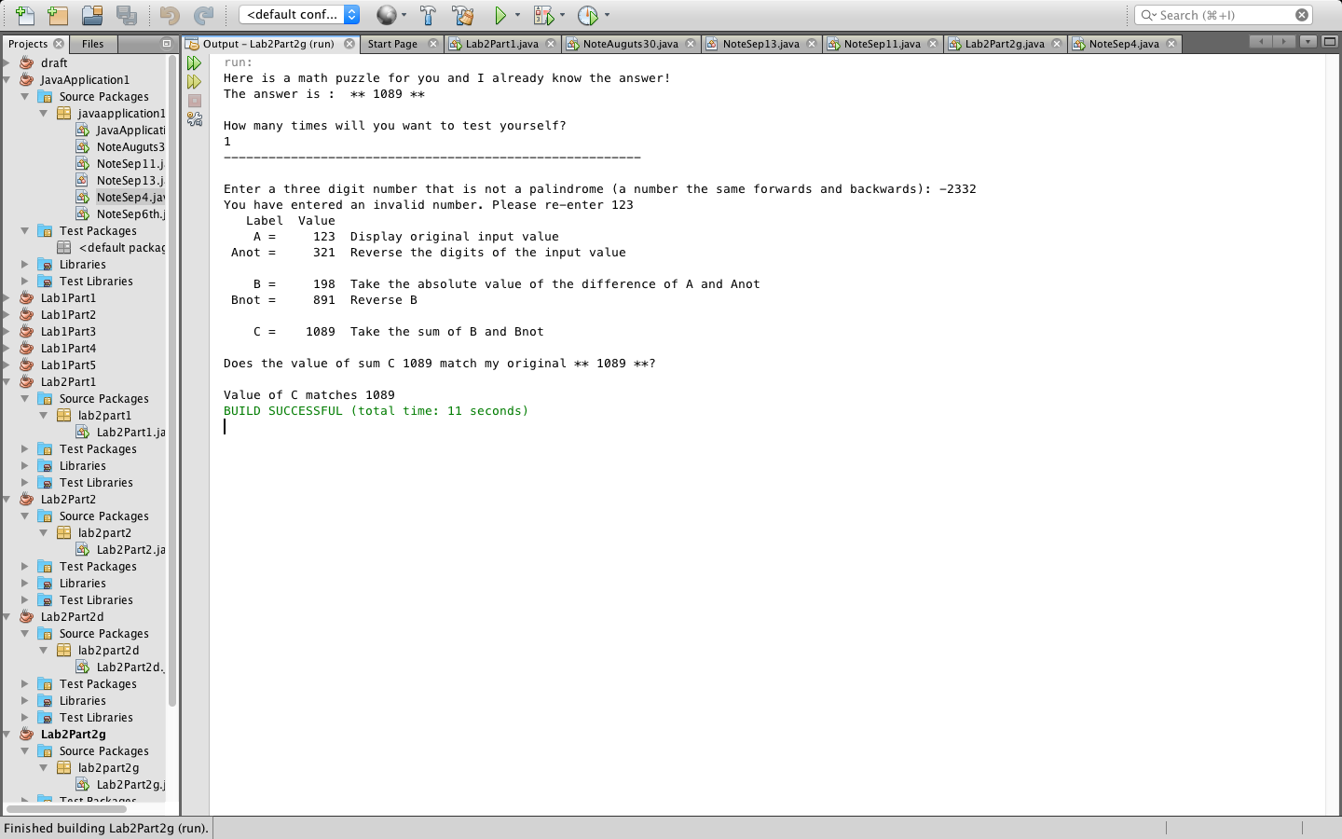

2.g.ii) Yes, the palindrome checking code correctly handle invalid input value. It only works for the first time because we use if statement. If the user keep entering another palindrome, the program will run and give the math saying that Value of C does not match 1089.

2.g.iii) 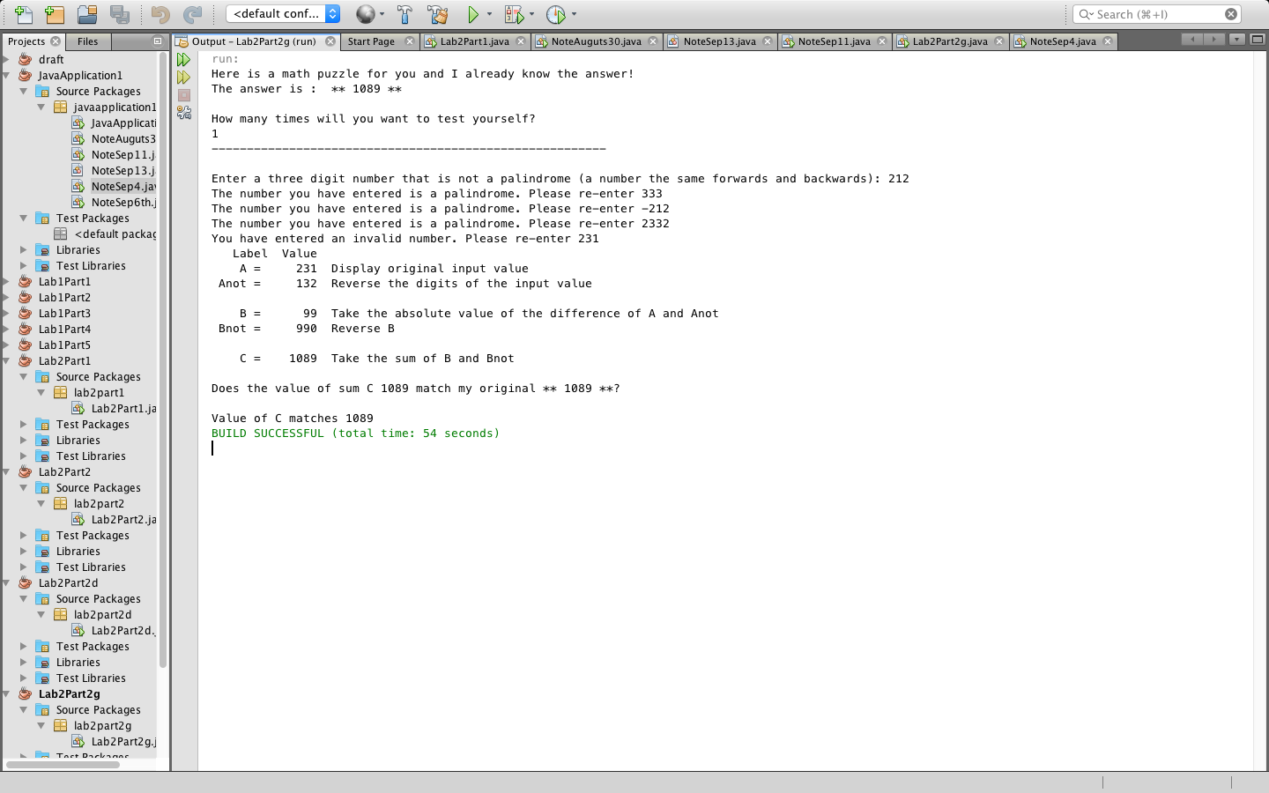

2.g.iv) Yes, the palindrome checking code cause the program to correctly handle invalid inputs because it will ask the user to enter a valid three-digit number that is not a palindrome until the input satisfied the requirement.



2.g.vii) Please see Lab2Part2g.java for this answer